New President and Trustees Appointed to the Australian Museum Trust
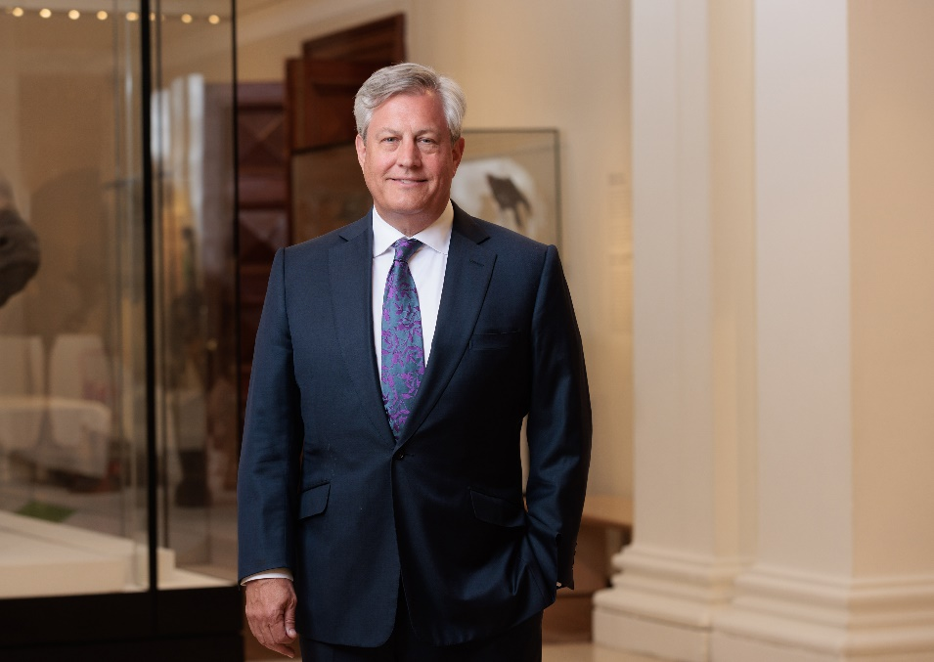

22 December 2022 Sydney: NSW Minister for the Arts, the Hon Ben Franklin MLC, today announced four new Trustees to the Australian Museum (AM) Trust and the appointment of Trustee Brian Hartzer as new AM Trust President.

Mr Hartzer joined the AM Trust in December 2020 and for the past two years has also served as Chairman of the Australian Museum Foundation (AMF). Mr Hartzer, a businessman from the finance sector, has had a long association with the AM, having been the prime supporter of the AM’s iconic Westpac Long Gallery renovation as CEO of Westpac in 2017. Mr Hartzer succeeds David Armstrong, whose nine-year term on the Trust, including five years as president, has concluded.

“I’ve been captivated by the mission and collections of the AM, the nation’s first museum, along with its place in our history. My family and I have always enjoyed visiting the AM, especially since its recent renovation. I’m looking forward to leading the AM Trust through an exciting period following record visitation, free general admission and the impact of the Project Discover transformation,” Mr Hartzer said.

The four new Trustees appointed to the AM Trust include Professor Shirley Alexander AM (education Trustee), former Deputy Vice Chancellor Education, University of Technology Sydney, Mr Brett Clegg, a former media executive and former chair of the Sydney Dance Company, Ms Jenny Dalitz, an accountant and nonexecutive director who will chair the AM Audit and Risk Committee and Mr David Feetham, Deputy Chairman of Gresham's corporate advisory business, Gresham Advisory Partners Limited.

Mr Hartzer leads a distinguished group of Trustees, whose terms on the AM Trust continue. The AM also thanks retiring AM Trust President Mr David Armstrong and Trustees Mr Steven Gregg, Dr Rod Kefford AM, FACE, and Ms Sara Watts, for their dedicated service.

From 2023, the AM Trust includes: Brian Hartzer, AM Trust President, Professor Shirley Alexander AM, Distinguished Professor Larissa Behrendt AO, Professor Kathy Belov AO, Jennifer Bott AO, Maile Carnegie, Brett Clegg, Jenny Dalitz, David Feetham, Shauna Jarrett, and Josephine Sukkar AM.
1/2
Australian Museum Director and CEO, Kim McKay AO said the AM Trust plays an important role in helping frame the strategic direction of the nation’s first museum.

“David Armstrong and the other retiring Trustees have played an extraordinary role in helping to shape the future of the AM during a time of transformation due to Project Discover. The AM is now a museum of which we all can be proud and I’m looking forward to a new group of Trustees joining the board under Brian Hartzer’s leadership,” McKay said.

“2023 will be another record-breaking year for the AM and the advice and input of our Trustees will contribute hugely to the AM’s ongoing success,” McKay added.

Trustees play a valuable role in monitoring the governance performance of the AM, assisting with strategic planning processes and acting as advocates for the institution. They are appointed for three-year terms with a maximum of nine consecutive years of service. The Governor of NSW, in consultation with the Minister for the Arts, appoints the AM Trustees.

ENDS

About the Australian Museum
The Australian Museum (AM) was founded in 1827 and is the nation’s first museum. It is internationally recognised as a natural science and culture institution focused on Australia and the Pacific. The AM’s mission is to ignite wonder, inspire debate and drive change. The AM’s vision is to be a leading voice for the richness of life, the Earth and culture in Australia and the Pacific. The AM commits to transforming the conversation around climate change, the environment and wildlife conservation; to being a strong advocate for First Nations cultures; and to continuing to develop world-leading science, collections, exhibitions and education programs. With 22 million objects and specimens and the Australian Museum Research Institute (AMRI), the AM is not only a dynamic source of reliable scientific information on some of the most pressing environmental and social challenges facing our region, but also an important site of cultural exchange and learning.

2/2

