Celebrating Three Scientific Trailblazers with Lifetime Achievement Awards
Brian Sherman AM, Professor William Sherwin and Dr Val Attenbrow Announced as
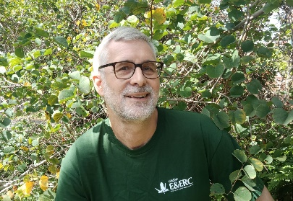
Australian Museum Research Institute (AMRI) Lifetime Achievement Award Recipients 2020-2022
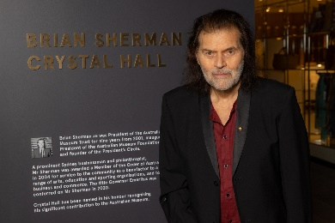
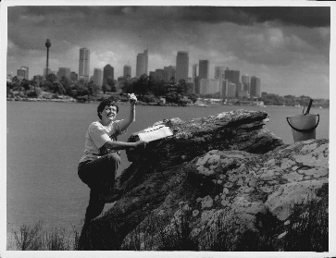

Brian Sherman AM, 2022 Recipient Professor William Sherwin, 2021 Recipient Dr Val Attenbrow, 2020 Recipient

Sydney, Wednesday 20 July 2022: A leading science and arts philanthropist, an eminent molecular ecologist and a legendary archaeologist are the three recipients of the Australian Museum Research Institute (AMRI) Lifetime Achievement Award announced this week.

Brian Sherman AM, a former Australian Museum (AM) Trust President and founding Chairperson of both the Australian Museum Foundation and the President’s Circle of donors is the 2022 AMRI Lifetime Achievement Award recipient; Professor William Sherwin, UNSW Sydney Molecular Ecologist, is the 2021 AMRI Lifetime Achievement Award recipient; and Dr Val Attenbrow, Senior Fellow, Geosciences and Archaeology at the AM, is the 2020 AMRI Lifetime Achievement Award recipient.

The AMRI Lifetime Achievement Award recognises eminent researchers and others who have made outstanding contributions to advancing public knowledge and understanding of science. Established in 2014, the announcement of the awards were delayed for the past three years due to COVID-19 pandemic.

Director and CEO of the Australian Museum, Kim McKay AO, said it is important for science and scientists be recognised in this way and to have a strong voice so that their work continues to be supported and trusted by the community and government.

Scientific and humanities research is the key to our existence and continued prosperity. Today, we celebrate and pay tribute to the achievements of these three leaders and their work, which continues to have a transformative impact on our society,” McKay said.

Australian Museum Chief Scientist, and leading mammalogist, Professor Kristofer Helgen, said that the award recipients have helped further our understanding of molecular biology, First Nations knowledge systems and public knowledge of science through philanthropic support.

“Through their dedication and commitment to scientific excellence, the winners have not only developed science-based solutions to address global concerns but have also raised the profile of the impact of science,” Professor Helgen said.

Prominent Sydney businessman and philanthropist, Brian Sherman AM, is the recipient of the 2022 AMRI Lifetime Achievement Award. Brian was President of the Australian Museum Trust from 2001 to 2009, ensuring the AM continued to be world-leading in its collections and scientific research. Since then, his legacy with the AM has continued to grow. Together with his wife Gene through the Sherman Foundation, Brian’s support for the future vision of the Australian Museum continued with a $1M gift towards Project Discover with the naming of the Brian Sherman Crystal Hall, and support of the Australian Museum Eureka Prizes. 1/3

“The Australian Museum makes a significant contribution to Sydney’s scientific and cultural life. For almost 200 years, the Museum has educated and inspired Sydneysiders and visitors with exhibitions of work from - and research projects relating to - its incredible collections,” Sherman said.
UNSW Sydney Molecular Ecologist Professor William Sherwin is the recipient of the 2021 AMRI Lifetime Achievement Award for his contributions to the AM’s Australian Centre for Wildlife Genomics (ACWG). In a massive boost to the ACWG’s Frozen Tissue Collection, Professor Sherwin donated more than 11,000 vertebrate tissue and DNA samples accumulated throughout his years of research – making it one of the largest and most significant donations of its kind and significantly building the AM’s genomic research capacity.

Professor Sherwin has dedicated almost 40 years to scientific research, with 30 of those years in various roles at the School of Biological, Environmental and Earth Sciences (BEES) at UNSW, Sydney.

“Awards are always a team effort and my team and I have collaborated with mathematicians and physicists to find new ways of assessing genetic biodiversity,” Professor Sherwin said.

“I was astonished and delighted to receive this award, and offer sincere thanks to the Australian Museum, my team and my nominators,” said Professor Sherwin.

Dr Val Attenbrow, Senior Fellow, Geosciences and Archaeology at the Australian Museum, is the recipient of the 2020 AMRI Lifetime Achievement Award. Dr Attenbrow has been a researcher at the AM since 1989. Her research, which has focused on Holocene period subsistence patterns, resource use, stone tool technology and trade among First Nations peoples, has had a profound impact on Australian archaeology.

Dr Attenbrow, who is well regarded by First Nations Peoples throughout south-eastern Australia, conducts research revealing rich and detailed information about life in the Sydney Basin, including game-changing studies on ground-edged artefacts (e.g. stone axes and hatchets), and flaked tools known as backed artefacts.

“Over the course of my career, there’s been many joyous moments and archaeology has become somewhat of a passion with me. But one of the most special moments has been receiving the AMRI Lifetime Achievement Award – that would certainly be on the top of the list,” Dr Attenbrow said.

The AMRI Lifetime Achievement Award was established in 2014 to acknowledge those who have played a significant part in science at the Australian Museum across the decades. Previous recipients of the AMRI Lifetime Achievement Award have included Mr Robyn Williams AM, Professor Tim Flannery, Professor Frank Talbot AM, the 1971 Lord Howe Island Environmental Survey Group, Catherine Livingstone AO and Professor Lesley Hughes.

Professor Sherwin and Dr Attenbrow will be honoured in a special online award ceremony for the 2020 and 2021 AMRI Lifetime Achievement Awards. The AM will present Brian Sherman and his family with the 2022 AMRI Lifetime Achievement Award in August. Learn more about the AMRI Lifetime Achievement Award and watch the award ceremony: https://australian.museum/get-involved/amri/lifetime-achievement/.

#ENDS#

2/3

ABOUT BRIAN SHERMAN
An inspirational leader, Mr Sherman was President of the Australian Museum Trust from 2001 to 2009 and the founding Chairperson of both the Australian Museum Foundation and the President’s Circle of donors, which are vital to enabling the Australian Museum to deliver its vision to be a leading voice for the richness of life, the Earth and culture in Australia and the Pacific.

Mr Sherman was made a Member of the Order of Australia (AM) in 2004 for service to the community as a benefactor to a range of arts, education, and sporting organisations, and to business and commerce. In 2020, on behalf of the NSW Government and the Australian Museum Trust, Mr Sherman was made Governor Emeritus in recognition of his contribution to the Australian Museum.

Mr Sherman’s many leadership roles within the Australian Museum raised the profile of museum science, education and the arts. During his time as President, Mr Sherman oversaw the acquisition of countless valuable specimens and objects, ensuring the Australian Museum continued to be world-leading in its collections and scientific research. Mr Sherman led the development and delivery of the Australian Museum Research Institute building which vastly improved storage facilities of millions of specimens and upgraded the Australian Museum’s scientific research facilities.

ABOUT PROFESSOR WILLIAM SHERWIN
UNSW Sydney molecular ecologist Professor William (Bill) Sherwin has dedicated almost 40 years to scientific research, applying mathematics to genetics and ecology to measure and predict how environmental changes – such as lost habitat, changing climate or the impact of invasive species – affect certain species.

His research has encompassed findings such as pinpointing the likely source of an invasive weed as well as important fieldwork on species such as koalas, wombats, prawns, and penguins. But of course, this is just a tiny snapshot of Prof. Sherwin’s work with his research spanning decades.

Prof. Sherwin’s multidisciplinary team introduced information theory methods to forecasting and measuring biodiversity levels from molecules to ecosystems. This method is used by many researchers and underpins the work of Prof. Sherwin’s lab on the molecular diversity of endangered, pest, and harvested wildlife.

ABOUT DR VAL ATTENBROW
Dr Attenbrow has been a researcher at the Australian Museum since 1989 and throughout her career, she has worked successfully with First Nations Peoples, involving community members in the day-to-day aspects of fieldwork and analysis.
She has also strongly championed the use of Aboriginal place names in popular contexts. Her cooperative research covers many aspects of the NSW past, including stone artefact technology and use-wear, geology, land and marine fauna, population history, and ethnography.
Dr Attenbrow’s significant contributions to Australian archaeology and her lifetime of accomplishments continue to inspire her students, colleagues and all who meet her.
About the Australian Museum
The Australian Museum (AM) was founded in 1827 and is the nation’s first museum. It is internationally recognised as a natural science and culture institution focused on Australia and the Pacific. The AM’s mission is to ignite wonder, inspire debate and drive change. The AM’s vision is to be a leading voice for the richness of life, the Earth and culture in Australia and the Pacific. The AM commits to transforming the conversation around climate change, the environment and wildlife conservation; to being a strong advocate for First Nations cultures; and to continuing to develop world-leading science, collections, exhibitions and education programs. With 22 million objects and specimens and the Australian Museum Research Institute (AMRI), the AM is not only a dynamic source of reliable scientific information on some of the most pressing environmental and social challenges facing our region, but also an important site of cultural exchange and learning.

3/3

