Extremely rare fossils of ancient sea life found in Tasmania
Newly discovered species named after Doctor Who
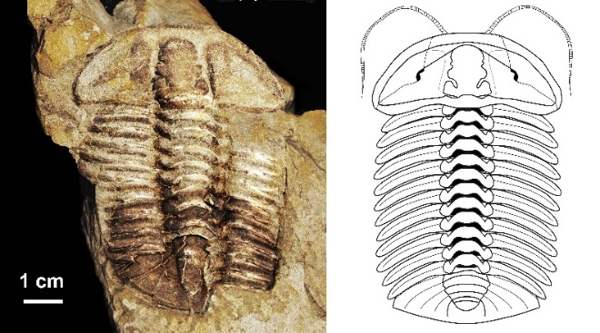
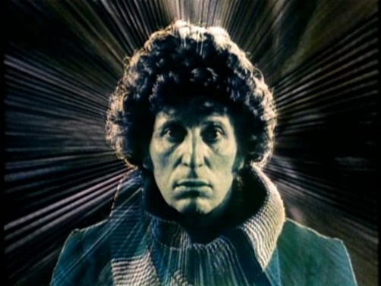

Trilobite – Graviclaymene bakeri Tom Baker as Doctor Who
Sydney, xx September 2020: Australian scientists, Dr. Patrick M. Smith, Australian Museum (AM) and Dr. Malte C.Ebach , University of NSW (UNSW), have named a newly discovered trilobite (extinct marine animal) after the actor Tom Baker, aka Doctor Who, Gravicalymene bakeri with the findings published today in the Alcheringa: An Australasian Journal of Palaeontology (TALC)
Found in the shales of the Gordon Group, Northern Tasmania, the rare trilobite is dated from the Late Ordovician period, part of the Palaeozoic era, approximately 450 million years ago. During this time, Australia was part of the great landmass Gondwana, when complex marine ecosystems were starting to develop. It was also a time when the first primitive plants were appearing on land.

Naming the new fossil after Tom Baker, Dr Smith said he was inspired to follow a career in science thanks to Baker’s particular incarnation of the character, Doctor Who.

“I’m not old enough to remember Tom Baker’s episodes which were originally aired in 1974-81. However, growing up as a teenager when the series re-aired in the early 2000’s, I followed the show religiously and became convinced that a career in science was guaranteed to improve the world,” Smith said.

“In particular, it inspired me to study the concept of ‘Time’ - as the Doctor travels through time. Hence, the area of science I specialised in is biostratigraphy which is all about dating the age of Earth and its rocks,” Smith added.

Mr Tom Baker was thrilled to hear the news that an ancient and incredibly rare specimen had been named in his honour.

“I am delighted to be entitled at last. I hope the Who World will share my joy. Will I be allowed to tack “Fossil” on official correspondence? I hope the Who World will celebrate this fresh honour and will spread the news to those who live in remote places. Happy days to all the Who fans everywhere,” Baker, who is based in the UK, said.

Co-author, Dr. Ebach, who first found the trilobites in the late 1990’s, said that palaeontologists often discover fossils in unusual circumstances.

1/3

“In the late 1990s I was caught short while driving through Gunns Plains in Tasmania. While relieving myself on a convenient boulder I noticed that it was covered in trilobites. Palaeontologists discover fossils in the most surprising ways,” Ebach admitted.

Also a Doctor Who fan, Ebach started watching Doctor Who in the 1970s and the repeats throughout the 1980s.

“It was the character of Doctor Who, and especially the actor Tom Baker, that inspired me to explore the natural world. So, it is a joy to name a trilobite in his honour. My sister-in-law has even knitted a replica Doctor Who scarf for the occasion,” Ebach added.

Arguably the second most famous fossil group after dinosaurs, trilobites are known by their distinctive three-lobed body. Their closest living relatives are segmented creatures such as crustaceans (e.g. prawns and crabs), chelicerates (e.g. spiders, scorpions, and mites), insects, millipedes, and centipedes.

While trilobites were common in Australia during the Ordovician Period, this new species is part of a group that has previously only been found in Europe and North America. This may suggest that Australia was somehow connected to these other continents by oceanic currents.

#ENDS#
Editorial information: Release and images here.
Quick Explainer:
What are Trilobites?
- Trilobites are hard-shelled, segmented marine creatures that existed over 520 million years ago in the ancient seas.
When did Trilobites come to life?
- Trilobites came to life during the Palaeozoic period – the first time period when complex life forms established to form the foundation of life. Here is a map of geological time scale
Where are Trilobites found?
- Trilobites are found in the rocks on all continents. Recently some were found by fossil enthusiasts in a rubbish dump in NSW!
Are Trilobites still alive today?
- Trilobites went extinct before dinosaurs came into existence.
What is Palaeontology?
- Palaeontology is the study of ancient life forms
For more information on fossils visit the Australian Museum .For more information on trilobites visit here.
Biographies:

Dr Patrick M. Smith is a Technical Officer in the Palaeontology Department of the Australian Museum and a research associate at Macquarie University. He is fascinated with the ability of fossils to tell geological time, a passion he developed after becoming fascinated with time travel whilst watching “Doctor Who” as a young child. Currently he is working on Cambro-Ordovician trilobites from Australia.
Dr Malte C. Ebach is a Senior Lecturer at the University of New South Wales. Currently he teaches geology, palaeontology and biogeography, and works on Australasian and Gondwanan biogeography.

2/3

About the Australian Museum
The Australian Museum (AM) was founded in 1827 and is the nation’s first museum. It is internationally recognised as a natural science and culture institution focused on Australia and the Pacific. As custodian of more than 21.9 million objects and specimens, the AM is uniquely positioned to provide a greater understanding of the region through its scientific research, exhibitions and public and education programs. Through the Australian Museum Research Institute (AMRI), the AM also has a leading role in conserving Australia’s biodiversity through understanding the environmental impacts of climate change, potential biosecurity threats and invasive species.

About the Australian Museum Research Institute
The research undertaken by the Australian Museum Research Institute informs decision making, policy and global, regional and national efforts to manage biological resources. The Australian Museum Research Institute’s work guides conservation management decisions including management of wild and captive populations of endangered species, protected areas, natural resources such as marine fishing grounds and land restoration.

3/3

