FORTY AUSTRALIAN FROG SPECIES THREATENED WITH EXTINCTON:
HELP COUNT AUSTRALIA’S FROGS THIS FROGID WEEK AND HELP SAVE THEM
FRIDAY 11- SUNDAY 20 NOVEMBER 2022
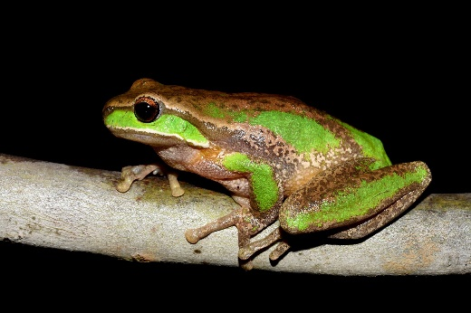
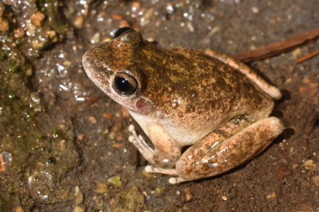
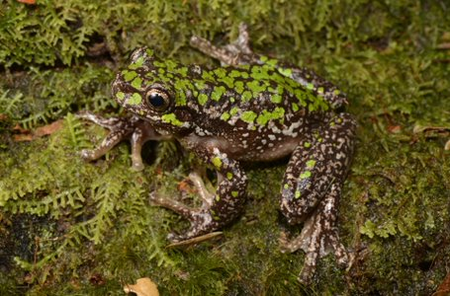
Tasmanian Tree Frog, Litoria burrowsae
Photo by Dr Jodi Rowley

Booroolong Frog, Litoria booroolongensis
Photo by Dr Jodi Rowley

Davies’ Tree Frog, Litoria daviesae
Photo by Dr Jodi Rowley
Sydney, 10 November, 2022; Forty of Australia’s 246 native frog species are on the edge of extinction, with four sadly already extinct, due to habitat loss, pollution, disease and climate change, seriously impacting the health of the country’s waterways and ecosystems.

The recent rainfall and flooding across the country over the last 12 months has not only wreaked havoc on the lives of Australian communities, but also impacted frog habitats, particularly stream frogs who are more threatened and at risk from floods. Now more than ever, urgent support and research into our native frog populations is needed.

This FrogID Week (11-20 November), the Australian Museum is calling on the public to help save Australia’s frog populations by recording frogs living in backyards, local parks and bushlands using the free FrogID app.

The Australian Museum’s FrogID citizen science project allows anyone with a smartphone to play an important role in understanding and monitoring Australia’s frogs. Participants simply record and submit the sounds of frog calls with the free FrogID app for the Australian Museum’s research team to identify, adding to the growing understanding of how frogs are coping against a myriad of threats.

In 2021, together tens of thousands of Australians recorded over 20,000 audio files resulting in 37,000 new frog records. This year – the fifth annual FrogID Week – the Australian Museum’s scientists are encouraging a wider cross section of the population to get involved to create an even stronger picture of the country’s unique frogs.

Dr Jodi Rowley, Lead Scientist for FrogID and Curator of Amphibian and Reptile Conservation Biology at the Australian Museum and UNSW Sydney, said this FrogID Week is critical in helping Australia’s frogs.

“Frogs are part of one of the most threatened groups of animals on Earth – hundreds of species have already disappeared and many more are under threat,” Dr Rowley said.

“The Museum has established a nationwide database of Australian frog calls, to monitor their distributions, breeding seasons and breeding habitats over time. That’s where the public comes in – by putting more frog calls on the map, particularly in regional and remote areas, we can better understand and conserve frogs.

“People power through citizen science helps us understand the health of frog populations, and because frogs are great bioindicators, the health of our environment.”

Kim McKay AO, Director and CEO at the Australian Museum, said while FrogID is still in its early years, the information being gathered by the Australian public is already playing a valuable role in helping frogs.
“This year, the Museum has reached the milestone of over 700,000 Australian frog call records since the project began,” Ms McKay said. “This remarkable, quality ‘audio shot’ of the status of Australia’s frogs is thanks to ordinary people.”

“Whether you’re a frog expert, or are completely new to frogs, get involved! Every FrogID recording contributes to our national understanding of Australia’s frog species and builds the information that the scientists and land managers need to help understand and conserve our unique amphibians.”

This year, FrogID Week is focused on:

Gathering audio of calls from 19 local government areas around the country which are still not represented in the national FrogID database:

- Northern Territory – Belyuen
- Queensland – Cherbourg, Croydon, Doomadgee, Mapoon, Palm Island, Richmod, Woorabinda, Wujal Wujal
- South Australia – Cleve, Franklin Harbour, Kimba, Maralinga Tjarutja, Roxby Downs
- Western Australia – Dumbleyung, Morawa, Nungarin, Sandstone

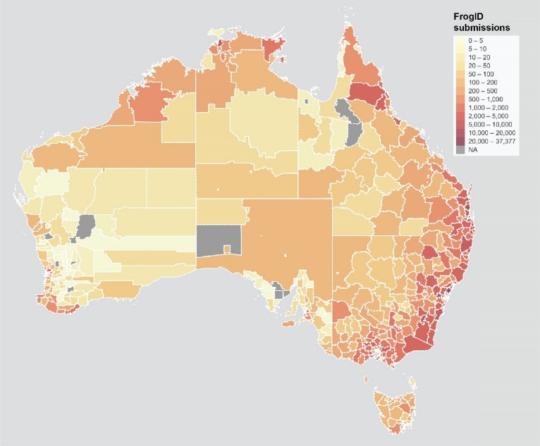
Map of number of FrogID submissions per local government area

- Learning more about stream frog species as a priority, with the NSW Department of Planning and Environment – Water a proud supporter of FrogID Week 2022. Many of the species in decline depend on streams, creeks and other waterways for survival.
- Stream frog species include:
- NSW + QLD - Tusked Frog, Adelotus brevis
- NSW + VIC - Southern Green Stream Frog, Litoria nudidigita, Southern Barred Frog, Mixophyes balbus, Giant Burrowing Frog, Heleioporus australiacus
- NSW + ACT - Green Stream Frog, Litoria pyllochroa, Giant Burrowing Frog, Heleioporus australiacus
- NT + WA - Bilingual Froglet, Crinia bilingual, Woodworker Frog, Limnodynastes lignarius, Rockhole Frog, Litoria meiriana
- NT + WA + QLD - Copland’s Rock Frog, Litoria coplandi
- SA - Northern Flinders Ranges Froglet, Crinia flindersensis, Southern Flinders Ranges Froglet, Crinia riparia
- WA - White-bellied Frog, Anstisia alba, Roseate Frog, Anstisia rosea
- QLD -Cape York Graceful Tree Frog, Litoria bella
- NSW - Davies’ Tree Frog, Litoria daviesae, New England Tree Frog, Litoria subglandulosa, Booroolong Frog, Litoria booroolongensis
- TAS - Tasmanian Tree Frog, Litoria burrowsae

How does FrogID work?

Every species of frog makes a unique call – it’s the male frog’s way of attracting a female frog. In order to mate, most frogs need water. So, if there’s water, there’s usually frogs around. In November each year, depending on rainfall, most parts of Australia should hear frog calls.

You simply use the FrogID app to record the sound of a frog call and submit it using your mobile phone. Every audio recording of a frog call submitted to FrogID is identified by one or more species experts at the Australian Museum. These records not only increase our understanding of the true distribution of Australia’s frog species, but they also reveal what breeding conditions and habitats different frog species need.

How to take part in FrogID Week:

To be involved in FrogID Week, download the free FrogID app and record frog calls from your backyards, dams, and bushland, as often as you can during the period 11-20 November and beyond.

FrogID allows us to record frogs safely with minimised disturbance to frogs and their habitat. It’s important to clean and disinfect footwear between habitats, to avoid spreading frog germs.

You never know – you might help discover the next Australian frog species.

There’s also a competition for the “Top Frogger.” Record and submit the most frog calls during FrogID Week and you could win a FrogID prize pack valued at $235.

In collaboration with The Bowerbird Collective, the Australian Museum’s Songs of Disappearance is available to pre-order this FrogID Week – an album featuring the calls of over 50 unique and threatened frog species, including recordings from FrogID citizen scientists across Australia. Available to pre-order as a digital download or as a physical copy ahead of its December 2 release date, album proceeds support the FrogID project. If purchased before November 17, you could help frogs hop into the ARIA charts.

FrogID is proudly funded by the NSW Biodiversity Conservation Trust, Department of Planning and Environment – Water and Saving our Species and supported by Museum partners across Australia.

More information: https://www.frogid.net.au/frog-id-week

ENDS
Media contacts
Claire Vince, Media and Communications Adviser claire.vince@australian.museum / 0468 726 910
Matt Fraser, Director, Original Spin matt@originalspin.com.au / 0401 325 007
Photos, audio and video of Australian frogs: https://foto.australian.museum/

About FrogID
FrogID is Australia’s national frog count. It’s a scientific rescue mission that everyone can be involved in, any time of year. The multi-year citizen science project is led by the Australian Museum Centre for Citizen Science, which encourages the public to make a meaningful contribution to our scientific understanding of the world. The free FrogID app was initially developed in partnership with IBM in 2017. The app enables anyone with a smartphone to record different frog species by the unique sounds they make. These recordings provide data on the health of Australia’s frog populations and identify species that are at risk, to assist and inform conservation efforts. FrogID received funding from the Australian Government under the Citizen Science Grants element of the Inspiring Australia – Science Engagement Programme between 2017-2020. The Australian Museum in Sydney NSW is leading FrogID in partnership with natural science museums in NT, QLD, SA, TAS, VIC and WA. NSW Government proudly supports FrogID in 2022-23, including the Biodiversity Conservation Trust, Department of Planning and Environment - Water, and Saving our Species.
About the Australian Museum (AM)
The Australian Museum (AM) was founded in 1827 and is the nation’s first museum. It is internationally recognised as a natural science and culture institution focused on Australia and the Pacific. The AM’s mission is to ignite wonder, inspire debate and drive change. The AM’s vision is to be a leading voice for the richness of life, the Earth and culture in Australia and the Pacific. The AM commits to transforming the conversation around climate change, the environment and wildlife conservation; to being a strong advocate for First Nations cultures; and to continuing to develop world-leading science, collections, exhibitions and education programs. With 22 million objects and specimens and the Australian Museum Research Institute (AMRI), the AM is not only a dynamic source of reliable scientific information on some of the most pressing environmental and social challenges facing our region, but also an important site of cultural exchange and learning.

