1800 Spectacular Minerals Return to the Australian Museum in New Gallery
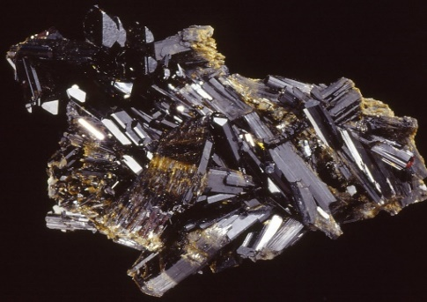
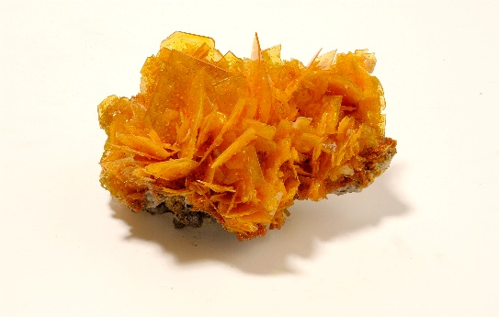
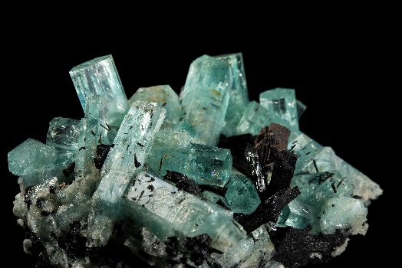
New Minerals Gallery opens FREE to the public Saturday 10 December 2022

Aquamarine from Namibia Wulfenite from South America Epidote from Austria

Friday 9 December 2022 Sydney: Today, the Australian Museum (AM) opened its new permanent Minerals Gallery, with over 1800 magnificent and rare specimens on exhibition, some for the first time. Part of the AM’s transformative renovation and expansion made possible as part of Project Discover Stage Two. Supported by the NSW Government, the new gallery will showcase mineral treasures which represent a wide selection of the world’s known mineral specimens.

Officially opened by NSW Minister for the Arts and Tourism, the Hon. Ben Franklin MLC, Minerals tells the story of both the AM’s outstanding Australian and international minerals and rocks collection in a way that reflects the spirit and knowledge of the Museum’s dedicated scientists, past and present.

Mr Franklin said the new Minerals gallery will be among the nation’s pre-eminent destinations for enjoying and learning about these scientifically fascinating and aesthetically beautiful objects, which form so much of our nation’s geological and economic history.

“As part of our government’s mission to take financial pressure of families, increase access to science and culture and lay a foundation for life-long learning, the new Minerals Gallery is free for all museum visitors and a great way to kick off your summer holidays,” Mr Franklin said.

“The NSW Government is committed to improving the lives of our people and providing opportunities for everyone to enjoy our arts and cultural experiences. The Australian Museum not only offers a rich, cultural experience but also a dynamic, learning environment. Showcasing Australia’s rarely seen gems and minerals, the new Minerals gallery offers insights into how minerals form their shape, lustre and size. It will provide a place for families to connect and inspire imaginations to run wild in the revitalised Australian Museum spaces.”

Kim McKay AO, Director and CEO, Australian Museum, said the Minerals gallery unearths the beauty, colour and vibrancy of these precious minerals and gems while showcasing the creation of our world.

“Visitors will not only gain a deeper appreciation of the gems and rare minerals that they know and love, but they will also learn about “out of this world” meteorites and the key aspects of mineralogy and the critical roles minerals play in everything from transport to smart phones,” McKay said

1/2

Minerals Collection Manager, Ross Pogson said that the extraordinary beauty and composition of the specimens is truly a bridge between art and science.

“I hope that the minerals will sparkle in our visitor’s eyes, just as they did for me, creating a lifelong commitment for learning more about where these rare minerals come from, how they’re made and why they grow in these astonishing shapes,” Pogson said.

Located on level one of the AM covering approximately 350sqm, Minerals features 1,800 specimens from the AM’s collection of more than 80,000, one of the largest mineral and rock collections in Australia. With themes and content curated and interpreted by the AM’s exhibition team led by Fran Dorey, and specimens selected by Ross Pogson and Geoscience Technical officer, Dayna McGeeney.

The rocks and minerals on display range from sparkling gemstones reflecting all the colours of the spectrum to the rare earth minerals that are essential today in modern battery and catalytic converter technology. The gallery is divided into five thematic sections featuring fun interactives:

- Minerals: an introduction: Introduces visitors to the building blocks of our planet – from elements to minerals and rocks; the basics of rocks and how minerals are classified and identified.
- Making minerals: A focus on the eight key environments and processes in which minerals are formed. Also includes human-made minerals, both deliberate and accidental.
- Collecting and collections: Showcases the AM Minerals collection and subsets of the AM collection such as Albert Chapman, Mawson/Antarctic Collection and Ornamental minerals.
- Survivors from Deep Time: Earth’s oldest rocks and minerals, including visitors from outer space, and what they reveal about how the solar system formed.
- Minerals and us: How humans impact the Earth and how minerals/rocks impact humans. Includes negative impacts of mining and climate change alongside Australian European and Indigenous mining histories and key sites; how humans use minerals (now and in the past) and the AM’s spectacular gemstone collection.

Minerals opens FREE to the public on Saturday 10 December 2022. The learning doesn’t end there. Through the Museum’s comprehensive curriculum-based earth sciences and geology education programs, the next generation are being inspired to enter careers in emerging STEM industries.

A catalogue, Mineral Icons of the Australian Museum, will accompany the permanent gallery and is available for purchase at the AM Shop ($49.95).

The new Minerals Gallery is supported by the NSW Government as part of the Australian Museum's major transformation, Project Discover, and also funded by the Australian Museum Foundation.

EDITORS NOTE; Photos and further information on minerals here
School holidays program here
ENDS

About the Australian Museum
The Australian Museum (AM) was founded in 1827 and is the nation’s first museum. It is internationally recognised as a natural science and culture institution focused on Australia and the Pacific. The AM’s mission is to ignite wonder, inspire debate and drive change. The AM’s vision is to be a leading voice for the richness of life, the Earth and culture in Australia and the Pacific. The AM commits to transforming the conversation around climate change, the environment and wildlife conservation; to being a strong advocate for First Nations cultures; and to continuing to develop world-leading science, collections, exhibitions and education programs. With 22 million objects and specimens and the Australian Museum Research Institute (AMRI), the AM is not only a dynamic source of reliable scientific information on some of the most pressing environmental and social challenges facing our region, but also an important site of cultural exchange and learning.
2/2

