STAR STUDENTS CITED IN SCIENCE RESEARCH
Climate change impacts identified by school scientists, backed by museum collections.
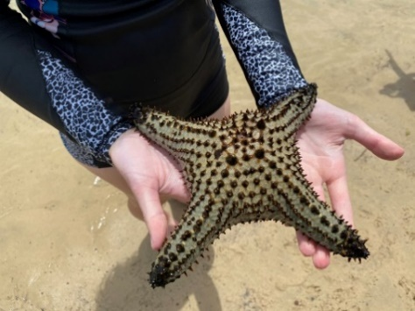
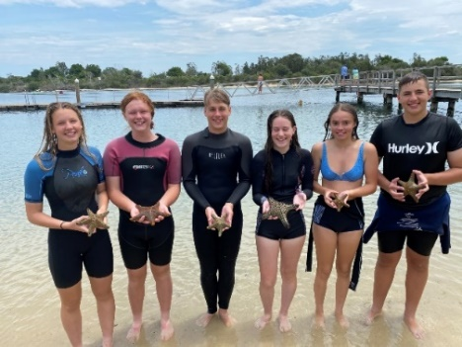

24 January, 2022, Sydney; The work of students from Great Lakes College, Tuncurry, mid-north coast, NSW, has provided scientists from the Australian Museum (AM) and the Smithsonian Institution, Washington, DC, (USNM) with evidence that the tropical sea star, Pentaceraster regulus, has increased its distribution range into south eastern Australian coastal waters. The peer reviewed research was published in the AM’s Technical Reports in December, 2021.
Lead authors of the research paper, AM Marine Invertebrates Collection Manager, Dr Stephen Keable and Researcher, Invertebrate Zoology, Smithsonian Institution, Dr Christopher Mah said they combined historical data from the Australian Museum’s renowned marine collections with the recently obtained specimens discovered by the students.
“The specimens found by the students and additional observations led us to conclude that the sea star, Pentaceraster regulus, normally occurring in tropical waters further north, has now established itself in Wallis Lake,” Keable said.
“As there is considerable difference between the smallest and largest specimens present, it does suggest a population that completes most, or all, of the life cycle in the estuary,” Keable added.
Records of this sea star from Wallis Lake now span a 12 year period, as the AM has two specimens of Pentaceraster regulus previously collected from Wallis Lake in 2008.
“Because there were only two individuals of this species found in 2008 it was thought that they may have been brought into the area by vessels entering the nearby marina,” Keable explained.
“However, the new information about the sea stars supplied by the students under the guidance of their teacher, Simon Patterson provides evidence that the presence of this species is not a one-off event. Examples such as this, of poleward range expansions south from tropical waters in the north, have previously been suggested as indicators of tropicalisation of the south-eastern Australian coastal waters due to climate change. Such expansions can have significant environmental and economic consequences” Keable added.
1/2
Patterson said the students saw some beautiful but unfamiliar sea stars and were determined to identify them.
“Their own research didn’t lead to any conclusions, so we contacted the Australian Museum. Dr Keable asked for help in collecting and preserving specimens, which the students did, preserving six in our laboratory for collection by the museum,” Patterson said.
“Their presence in the Lake now suggests a possible range shift for the species. It is a great thrill for the students to have their part in this important work recognised in the research paper,” Patterson added.
Dr Keable travelled to Wallis Lake, Tuncurry to obtain the specimens from the school, and collected more himself for the museum to help identify them and provide a reference for future comparisons. During his visit Dr Keable spoke to the students about his role at the AM, and about the science of taxonomy – classifying living things – as well as the impacts of climate change on our environment.
“Education programs such as these at the Great Lakes College, Tuncurry, which incorporate field expeditions, allow students to apply knowledge from the classroom to real life experiences. In this case, developing their observational skills to see things from a new perspective has provided the students, and now the public, with an increased understanding of one of the threats and how they can help safeguard our marine ecosystems and species,” Keable said.
Principal of Great Lakes College, Sally Chad, said the academic acknowledgement of the students’ work is testimony to their enthusiasm and thoroughness, and to the guidance of their science teacher, Simon Patterson.
“Intelligent curiosity is the seed of all new learning, and that’s exactly what the students showed while snorkelling in Wallis Lake in Term 4 last year,” Ms Chad said.
Chief Scientist and Director, Australian Museum Research Institute, Professor Kristofer Helgen said this research highlighted why museum collections and citizen scientists are vital to our understanding of our changing climate.

“Drs Keable and Mah have utilised our museum collection to show how our warming climate is affecting marine species. Data from our collections provides information on geographical distribution – as this study demonstrates, as well as timing of life cycle events, and are incredibly valuable in understanding how species are reacting to climate change,” Helgen said.

Editors note: images, science paper found here

# ENDS #
About the Australian Museum (AM)
The Australian Museum (AM) was founded in 1827 and is the nation’s first museum. It is internationally recognised as a natural science and culture institution focused on Australia and the Pacific. The AM’s mission is to ignite wonder, inspire debate and drive change. The AM’s vision is to be a leading voice for the richness of life, the Earth and culture in Australia and the Pacific. The AM commits to transforming the conversation around climate change, the environment and wildlife conservation; to being a strong advocate for First Nations cultures; and to continuing to develop world-leading science, collections, exhibitions and education programs. With more than 21.9 million objects and specimens and the Australian Museum Research Institute (AMRI), the AM is not only a dynamic source of reliable scientific information on some of the most pressing environmental and social challenges facing our region, but also an important site of cultural exchange and learning.
2/2

