Surprise discovery of two new, “very loud” frog species
Frog calls and DNA reveal the loudest Australian frog is not one but three different species
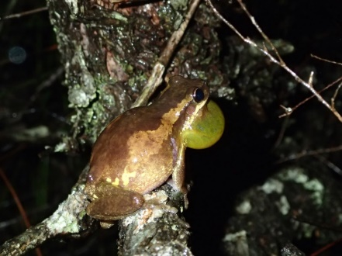
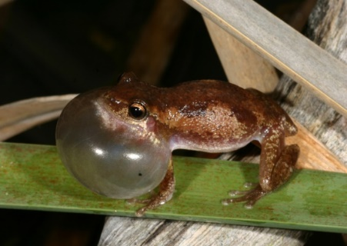

Slender Bleating Tree Frog ©H.B Hines Screaming Tree Frog © Jodi Rowley

22 November 2021, Sydney: Scientists from the Australian Museum in Sydney, the South Australian Museum, the University of Newcastle, Queensland Parks and Wildlife Service and other institutions, have found and described two new, very loud frog species from eastern Australia: the Screaming Tree Frog, Litoria quiritatus and the Slender Bleating Tree Frog Litoria balatus.

Published today in Zootaxa the newly described Slender Bleating Tree Frog is present in Queensland, including Brisbane, while the Screaming Tree Frog occurs from around Taree in NSW down the east coast to just over the border in Victoria.

Scientifically described with the help of citizen scientists and their recordings through the Australian Museum’s FrogID app, the new frog species were once thought to be one species, the Bleating Tree Frog, Litoria dentata.

Australian Museum and the University of NSW (UNSW), herpetologist and lead scientist on the groundbreaking FrogID project, Dr Jodi Rowley, said that Litoria dentata, the Bleating Tree Frog, is well known to residents along the east coast of Australia and in Sydney for its extremely loud, piercing, almost painful call.

“These noisy frog bachelors are super loud when they are trying to woo their mates,” Dr Rowley said.

The scientists analysed many calls submitted to the FrogID project from across Queensland and NSW to differentiate between the calls.

“Our examination revealed that their calls differ slightly in how long, how high-pitched and how rapid-fire they are. The Slender Bleating Tree Frog has the shortest, most rapid-fire and highest pitched calls,” Dr Rowley explained.

Chief Research Scientist at the South Australian Museum, Professor Steven Donnellan said that genetic work was the first clue that there were actually three species.

“Although similar in appearance, and in their piercing calls, the frogs are genetically very different. I’m still amazed that it’s taken us so long to discover that the loudest frog in Australia is not one but three species,” Professor Donnellan said.

The three species vary subtly in appearance. The Slender Bleating Tree Frog, as its name suggests, is slender in appearance, and has a white line extending down its side, and males have a distinctly black vocal sac.
1/2
The Screaming Tree Frog isn’t nearly as slender, has no white line extending down its side, and males have a bright yellow vocal sac. In the breeding season, the entire body of males of the Screaming Tree Frog also tend to turn a lemon yellow.

The Robust Bleating Tree Frog is most similar in appearance to the Screaming Tree Frog, but males have a brownish vocal sac that turns a dull yellow or yellowish brown when fully inflated.

Professor of Biology at the University of Newcastle, Professor Michael Mahony, who over his long career has developed a cryopreservation method – the first genome bank for Australian frogs, said the three closely-related species are relatively common and widespread.

“They are also all at least somewhat tolerant of modified environments, being recorded as part of the FrogID project relatively often in backyards and paddocks, as well as more natural habitats,” Professor Mahony said.

Dr. Rowley noted that these new frog species brings the total number of native frog species known from Australia to 246, including the recently recognized Gurrumuls’ Toadlet and the Wollumbin Pouched Frog.

“The research and help from our citizen scientists highlights the valuable contribution that everyone can make to better understand and conserve our frogs,” Dr Rowley said.

“How many more undescribed species in the ‘quiet achiever’ category are awaiting their scientific debut?,” Professor Donnellan said.

The paper’s publication coincides with the end of FrogID Week 2021, which ran Friday 12 November through to Sunday 21 November, which has resulted in more than 20,000 verified frog records by the public to date through the AM’s flagship citizen science project, FrogID.
#ENDS#

Images, Audio, Vision here: https://tinyurl.com/6z5bx4m
Research paper:
Rowley, J.J.L., Mahony, M.J., Hines, H.B., Myers, S., Price, L.C., Shea, G.M. & Donnellan, S.C. (2021). Two new frog species from the Litoria rubella species group from eastern Australia. Zootaxa. 5071: 1-41.

About FrogID
FrogID is the AM’s flagship citizen science project and was established with support from the Australian Government’s Citizen
Science Grants, IBM Australia’s Impact Grants program and the Australian Museum Foundation’s donors. FrogID has also been
made possible through the AM’s collaboration with Museum & Art Gallery of the Northern Territory, Museums Victoria,
Queensland Museum, South Australian Museum, Tasmanian Museum and the Western Australian Museum. The NSW
Biodiversity Conservation Trust (BCT) are proud supporters of FrogID Week 2021 and Vegepod and Australian Geographic are
FrogID Week 2021 Prize Partners.

About the Australian Museum (AM)
The Australian Museum (AM) was founded in 1827 and is the nation’s first museum. It is internationally recognised as a natural science and culture institution focused on Australia and the Pacific. The AM’s mission is to ignite wonder, inspire debate and drive change. The AM’s vision is to be a leading voice for the richness of life, the Earth and culture in Australia and the Pacific.
The AM commits to transforming the conversation around climate change, the environment and wildlife conservation; to being a strong advocate for First Nations cultures; and to continuing to develop world-leading science, collections, exhibitions and education programs. With more than 21.9 million objects and specimens and the Australian Museum Research Institute (AMRI), the AM is not only a dynamic source of reliable scientific information on some of the most pressing environmental and social challenges facing our region, but also an important site of cultural exchange and learning. 2/2

