A Vision for a Better Climate Future: the Talbot Oration Returns to the Australian Museum with a Look at Election Trends and the Power of Imagery
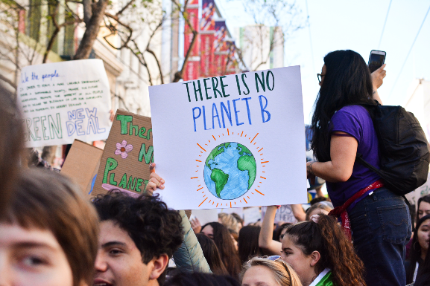
30 May 2022, Sydney: The Talbot Oration, one of the AM’s most important annual lectures, returns to the Australian Museum on Thursday 2 June at 6:30pm with respected author and social researcher, Dr Rebecca Huntley who will discuss the powerful way images convey the message of climate change and inspire action. Dr Huntley will also examine the recent impact of climate on election results.
Using data and evidence based on years of social trend research, Dr Huntley will offer reasons why the right imagery can break through online chatter and spark positive responses.
“Images of climate change have played an important part in raising our collective awareness on the plight of our environment. The polar bear floating on a lone iceberg, the koala with burnt paws, dead fish in dried up lakes – they have shown us that climate change is not just a scientific phenomenon but also a cultural and emotional one,” Dr Huntley said.
“In this digital age, too much of one thing – or the wrong thing, can make people just scroll on. How can we balance images of loss and devastation with images that inform people, bring them together and evoke climate action?” Huntley asked.
Dr Huntley said that the results of the national election have provided real momentum for clearer and more decisive action on climate change.
“Research before and after the election shows that climate was in the top three issues that mattered to Australians when they voted, along with the economy and cost of living,” Dr Huntley said.
“Climate has always been positioned as a post-material concern, something intangible for people without money problems to be worried about. But floods and fires, the opportunity with jobs and cheaper energy that renewables offer and the excitement around nature-based solutions to climate have shown that more and more Australians realise acting on climate is about protecting our quality of life and way of life,” Huntley explained.
Director and CEO, Australian Museum Kim McKay AO said that no city, state, or country is immune to the effects of climate change, and that hosting the annual Talbot Oration is part of the AM’s commitment to transforming the conversation around climate change.
“In quick succession, Australians have endured catastrophic droughts, fires and floods, and it is clear that faster action is needed to mitigate risks to our health, our environment and our way of life,” McKay said.
““The Australian Museum – informed by the scientists at the Australian Museum Research Institute, First Nations knowledge and the Museum’s own collections is committed to working with leaders like Dr Huntley so that we can draw upon expertise in data and analytics, response and resilience and play a major role in translating the climate science into action,” McKay said.
Following the address, Distinguished Professor Larissa Behrendt will host a panel of powerful champions of climate solutions: joining Dr Huntley will be Tishiko King, a proud Kulkalaig woman and campaigner for climate and social justice, and Dr Saul Griffiths, engineer and author of The Big Switch. Panelists will discuss practical solutions, underline the power of conversations and take questions from the audience.
The Talbot Oration honours the legacy of Professor Frank Talbot AM, an internationally renowned museum director, advocate for science and founder of the AM’s world leading Lizard Island Reef Research Station. Highlighting advances in the field of climate change research and environmental conservation, the annual Talbot Oration enables the public to better understand how responses to the climate challenge determine our future prospects, health, and the sustainability of our natural environment. The inaugural Talbot Oration in 2021 was delivered by the AM's Distinguished Fellow in Climate Change, Professor Tim Flannery. Listen to his speech here.
The Talbot Oration is free to attend however, spaces are limited. Visit the website to book tickets.
The Talbot Oration features as part of the Australian Museum’s Night at the Museum series where the AM invites guests to explore the AM with their friends from 5pm – 9pm, free of charge, every Thursday evening, until the end of June.
Nights at the Museum is proudly funded by the NSW Government.

EDITOR’S NOTES

More Information australian.museum/event/talbot-oration/

EVENT DETAILS
What: The Talbot Oration
When: Thursday 2 June, 6:30-8pm
Where: Australian Museum, 1 William St, Sydney NSW 2010

SOCIAL MEDIA
Facebook: @australianmuseum
Instagram: @australianmuseum
Twitter: @austmus
Hashtags: #australianmuseum

About the Australian Museum
The Australian Museum (AM) was founded in 1827 and is the nation’s first museum. It is internationally recognised as a natural science and culture institution focused on Australia and the Pacific. The AM’s mission is to ignite wonder, inspire debate and drive change. The AM’s vision is to be a leading voice for the richness of life, the Earth and culture in Australia and the Pacific. The AM commits to transforming the conversation around climate change, the environment and wildlife conservation; to being a strong advocate for First Nations cultures; and to continuing to develop world-leading science, collections, exhibitions and education programs. With more than 21.9 million objects and specimens and the Australian Museum Research Institute (AMRI), the AM is not only a dynamic source of reliable scientific information on some of the most pressing environmental and social challenges facing our region, but also an important site of cultural exchange and learning.

Dr Rebecca Huntley (Keynote Speaker)
Since seeing the 2018 school climate strikes and the impassioned agency and activism of the students, Huntley has shifted her attention to climate change. It inspired her to do what she could to make a difference to the lives of her three children and their generation, who will bear the responsibility of safeguarding the planet’s future. Huntley heads her own research and consultancy firm working closely with climate and environment NGOs, government and business on climate change strategy and communication.

Distinguished Professor Larissa Behrendt AO (Facilitator)
Larissa Behrendt is a Eualayi/Gamillaroi woman and the Director of Research and Academic Programs at the Jumbunna Indigenous House of Learning at the University of Technology, Sydney. She is a fellow of the Academy of Social Sciences in Australia and a founding member of the Australian Academy of Law. Behrendt was awarded the 2009 NAIDOC Person of the Year Award and 2011 NSW Australian of the Year.

Dr Saul Griffith (panelist)
Dr Saul Griffith is an inventor, author, and founder of multiple companies and non-profits. He has led projects for agencies including NASA, DARPA, National Science Foundation and more. He has founded and co-founded successful companies, including one acquired by Google, another by Autodesk, and another by a consortium of vehicle manufacturers including Toyota. In 2007 he was awarded a Macarthur Fellowship, the so-called ‘Genius Grant’, for inventions in the service of humanity.
Tishiko King (panelist)
Tishiko King is a proud Kulkalaig woman from the island of Masig, Kulkalgal Nation of Zendath Kes. Tish is a campaigner and organiser based on Naarm. She is spirited about sharing culture and amplifying social inequality and the rights of First Nations people.
During her studies in Ocean Science on the Gold Coast, Tish became passionate and actively involved with grassroots environmental groups and rallies across Australia and overseas. With experience across different industries at CSIRO Oceans and Atmosphere and the exploration and minerals industry, Tish brings a diverse perspective of First Nations and environmental justice.

