Priceless Archaeological Artefacts Found in Norfolk Island National Park by Local Citizen Scientist
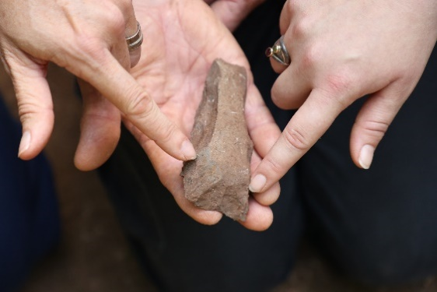
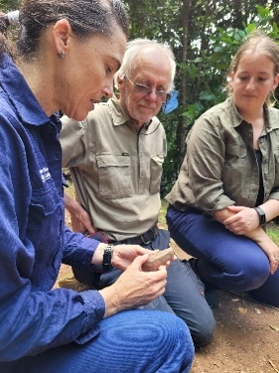
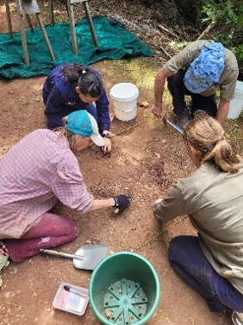

Photos: Tom Bannigan
Sydney, Saturday 29 October 2022: An archaeological dig on Norfolk Island has uncovered two Polynesian adzes (stone axes) and hundreds of flakes dating back to pre-European settlement. The adzes were used for wood working and canoe building and form hard evidence of settlement on Norfolk Island by the Polynesians during the 13th and 15th CE.*

Part of the Australian Museum’s first, broad scale, multi-pronged expedition of Norfolk Island, the first pieces of the treasure trove were uncovered by local Norfolk Islander, Snowy Tavener, who identified the site on the walking track in the Norfolk Island National Park more than four years ago.

“For many years, I’ve been walking this track searching for evidence of a new Polynesian site on our island, so when I came across these flakes I couldn’t believe my eyes,” Snowy said.

“The track is an extremely popular bushwalking path and has been driven and walked over for hundreds of years, but before we told the wider community about our find, I wanted it confirmed by archaeologists,” Snowy explained.

“I showed the site to my friend, Deb Jorgensen, who has a daughter, Nicola Jorgensen, studying Archaeology at the University of Sydney under Dr Amy Mosig Way from the Australian Museum, and the University of Sydney,” Snowy said.
“Nicola was immediately interested and so she and her supervisor came over last year to confirm that it was indeed a potential new Polynesian site,” Snowy added.
Now completing her Master’s degree, Jorgensen said the flakes and adzes are made from basalt and are a tangible link back to the Polynesian heritage of Norfolk Island.
“The number of artefacts not only indicates the level of activity that occurred on the site, but also confirms that this is another site made by the original Polynesian ancestors, with the other first settlement site being located at Emily Bay,” Jorgensen said.
Reflecting on the importance of the find, Jorgensen said it was exciting to her that this research commenced with local knowledge.

“I grew up here on beautiful Norfolk Island and like Snowy, feel proud to call it home. Local conservation efforts and preservation of our flora, fauna and historical sites can not only help advance scientific studies, but are also more likely to deliver positive outcomes for our community,” Jorgensen added. 1/3
Australian Museum archaeologist, Dr Mosig Way, said the significance of the discovery is that it demonstrates the extent of the Polynesian settlement across the island.
“No longer can the idea of Polynesians inhabiting the island be thought of as fleeting,” Dr Mosig Way said
“The artefacts can provide us with an understanding of the behaviours, the possessions and the movement of the former Polynesian inhabitants of Norfolk Island. And what is particularly exciting is the preservation of the artifacts, despite the traffic that has occurred on this track during the last few hundred years,” Dr Mosig Way explained.
Norfolk Island National Park Manager Nigel Greenup said that the discovery of the adze was significant.
“This discovery of an adze in Norfolk Island National Park indicates historical links with Polynesian people who first called Norfolk Island home – well before colonial settlement of the island,” Mr Greenup said.
“We will continue to work with the community and archaeologists to conserve this cultural heritage.”

Australian Museum Chief Scientist, Professor Kris Helgen, acknowledged that keen observations and persistence shown by Snowy has been the key to this extraordinary find.
“Incorporating local knowledge into our analysing and collecting methods is integral to the Australian Museum’s scientific research,” Helgen said.
“I am impressed not only by Snowy’s knowledge but also the enthusiasm and pride of the whole local community. I know we are all thrilled by these discoveries,” Helgen added.
Supported by Norfolk Island National Park Manager Nigel Greenup, Jorgensen, Snowy and Dr Mosig Way have carefully excavated, retrieved and recorded the items to ensure they are well-documented and conserved.
Once the dig is finished, the artefacts will be analysed and catalogued by the scientists with the findings and acknowledgement of the local community to be included in a scientific paper. The artefacts will initially be stored on Norfolk Island while a process of community consultation is undertaken to seek views on the long-term preservation and display of the items.

Funded through the Australian Museum Foundation, the Norfolk Island expedition is a collaboration with the Norfolk Island community, Parks Australia, the Australian Institute of Botanical Science and the Auckland War Memorial Museum.

Nicola Jorgensen’s project is supervised by Dr Amy Mosig Way, Scientific Officer, Archaeology, Australian Museum and University of Sydney.

Media Information:
Interviews, images, video interviews, vision and further information will be available here.
Australian Museum: Claire Vince - Claire.vince@australian.museum / 0456 728 910
Parks Australia: Chris Smyth – parksmedia@environment.gov.au / 0439 582 686

#ENDS#

2/3

About the Australian Museum
The Australian Museum (AM) was founded in 1827 and is the nation’s first museum. It is internationally recognised as a natural science and culture institution focused on Australia and the Pacific. The AM’s mission is to ignite wonder, inspire debate and drive change. The AM’s vision is to be a leading voice for the richness of life, the Earth and culture in Australia and the Pacific. The AM commits to transforming the conversation around climate change, the environment and wildlife conservation; to being a strong advocate for First Nations cultures; and to continuing to develop world-leading science, collections, exhibitions and education programs. With 22 million objects and specimens and the Australian Museum Research Institute (AMRI), the AM is not only a dynamic source of reliable scientific information on some of the most pressing environmental and social challenges facing our region,but also an important site of cultural exchange and learning.

About Norfolk Island National Park

The Norfolk Island National Park and Botanic Garden was declared in 1986 and now makes up 14 per cent of the land area of the island. The park is home to stunning scenery and walking tracks that take visitors on a journey through plant habitats found nowhere else on earth. The park features the tallest tree ferns on earth and Norfolk Island pines which grow up to sixty metres high. Amazing birdlife can also be found in the park, including the iconic and endangered Norfolk Island green parrot. The park’s team manages feral animals and weeds, rehabilitation of the park and protecting dozens of threatened plant and animal species. Norfolk Island National Park is managed by Parks Australia.

Acknowledgements
We acknowledge the Polynesian/Tupuna/Tipuna who first called Norfolk Island home whose story is still being written and pieced together. Through our work, we endeavour to add pages to their widely unknown narrative. We honour their connection this land/whenua and fauna in times gone by and invite them to guide and breathe life back into the treasures which they left for us to uncover and to piece together the story they did not tell.

We extend that acknowledgement to the descendants of the Pitcairn Islanders who still walk this land and whose Polynesian ties link them back to the East of the Great Ocean -Tahiti. We honour their Pacific story on this land, we acknowledge their Tupuna/Tipuna ancestors and the culture they forged here on Norfolk Island. A culture that continues to thrive today.

And finally, we acknowledge the other Pacific Island communities that now call this island home. The Pacific diasporas from across the Great Ocean – whose connection to this land may be more recent but whose presence also adds to the Pacific narrative of Norfolk Island in the here and now.

*Cite: Anderson, White 2001

3/3

