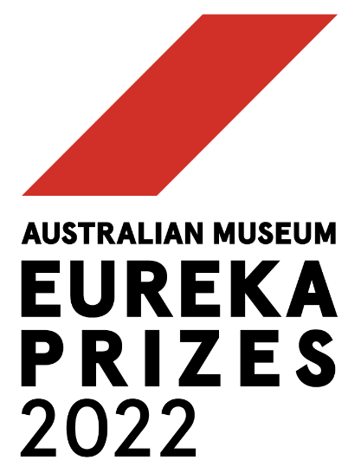
MEDIA RELEASE

YOUNG MINDS RECOGNISED IN SCHOOL SCIENCE CATEGORY AT 2022 AUSTRALIAN MUSEUM EUREKA PRIZES
From a musical look at COVID-19 variants, to environmental adaptation, and the sex lives of Clownfish, Sleek Geeks tell amazing scientific tales at Australia’s leading science awards
Sydney, 27 July 2022: The Australian Museum (AM) today announced the six “Sleek Geeks” selected in the School Science category at Australia’s premier science awards, the 2022 Australian Museum Eureka Prizes.
The School Science category of the AM Eureka Prizes showcases some of Australia’s best budding scientists from primary and high schools. Finalists in this category were selected based on their short video submissions on a scientific concept of their choosing, with films covering everything from methane greenhouse gases to the regenerative capacity of stem cells.

High school student finalists include:
- Aidi H., Tara K. and Ellen Z., Lauriston Girls' School, VIC, whose film tells the story of COVID-19 variants through song.
- Marissa C., Somerville House, QLD, who looks at the complex reproductive hierarchy of the Clownfish.
- Iestyn R., St John's Anglican College, Forest Lake, QLD, uses colourful graphics to explain how neurons connect via synapses.
Primary school student finalists include:
- Charlotte L., PLC Sydney, NSW, uses humour and engaging graphics to how the digestion of cows and sheep can be modified to drastically reduce their methane output.
- Zara M., PLC Sydney, NSW, uses colourful animations, expert interviews and an original experiment with a flatworm to demonstrate the regenerative capacity of stem cells.
- Genevieve S., Bucasia State School, QLD, examines how animals fit into their environment and what they must do to survive if their habitat changes.
The AM Eureka Prizes are the nation’s most comprehensive science awards, offering $140,000 in prize money across a broad spectrum of research, from environmental to innovative technologies, citizen science, leadership and mentoring.
The winners of the 2022 AM Eureka Prizes will be announced on Wednesday 31 August at an awards ceremony held at the Australian Museum. An online livestream of the awards will also be open to all audiences to view on the night. Register for the livestream at australian.museum/eurekaprizes.
For more information and a full list of 2022 Australian Museum Eureka Prizes finalists: australian.museum/eurekaprizes

THE 2022 AUSTRALIAN MUSEUM EUREKA PRIZE FINALISTS IN SCHOOL SCIENCE ARE:
University of Sydney Sleek Geeks Science Eureka Prize — Primary

Charlotte L., PLC Sydney, NSW
Cattle farming produces large amounts of the greenhouse gas methane, but a possible solution might live in the sea. In A More Polite Belch, Charlotte uses humour and engaging graphics to show that by adding the red seaweed, Asparagopsis, to animal feed, the digestion of cows and sheep can be modified to drastically reduce their methane output.

Zara M., PLC Sydney, NSW
In Stem Cells - Changing the Way We Heal, Zara uses colourful animations, expert interviews and an original experiment with a flatworm called Bob, to demonstrate the regenerative capacity of stem cells. She explains how pluripotent stem cells can become any type of cell in the body, with potential to promote growth and healing.

Genevieve S., Bucasia State School, Qld
In Adaptation: Now That's Change! Genevieve examines how animals fit into their environment and what they must do to survive if their habitat changes. Combining graphics and close encounters with cuddly — and not-so-cuddly — creatures, she shows how adaptations happen over time and the sort of features that develop to help animals thrive.

University of Sydney Sleek Geeks Science Eureka Prize — Secondary

Marissa C., Somerville House, Qld
Finding Nemo is a fun movie but in Sex Change in Clownfish, Marissa shows the science is a little fishy. Combining expert opinion with graphics to map their complex reproductive hierarchy, she explains that all clownfish have male and female reproductive organs. This means if a breeding female is lost, the dominant male can switch sex to replace her.

Aidi H., Tara K. and Ellen Z., Lauriston Girls' School, Vic
Aidi, Tara and Ellen tell the story of COVID-19 variants through song. Changing Corona describes how virus mutations are caused by errors during reproduction. Although this means that mutations will appear for as long as the virus reproduces, the filmmakers remind us that humans can also change and adapt to manage new variants.

Iestyn R., St John's Anglican College, Forest Lake, Qld
Brain scanning technology shows that the human brain can adapt throughout our lives. In his film Neuroplasticity - You Can Change Your Brain, Iestyn uses colourful graphics to explain how neurons connect via synapses. Through everyday examples, he shows that when connections become crowded with data, learning prompts an editing process that makes space for new information.

EVENT DETAILS
What: Australian Museum Eureka Prizes Award Ceremony
Where: Hintze Hall, Australian Museum, corner of College and William Streets, Sydney
Theatre style award ceremony attended by 400 guests and live broadcast online
When: Wednesday 31 August 2022
Live broadcast from 7:30pm AEST via australian.museum/eurekaprizes

Interviews available with finalists
Media pack, including releases, finalist info, images and video HERE

#EurekaPrizes
Twitter: @eurekaprizes Facebook: @eurekaprizes

MEDIA ENQUIRIES
Matt Fraser, Director of Communications
E: matt@originalspin.com.au M: 0401 326 007

#ENDS#

About the Australian Museum
The Australian Museum (AM) was founded in 1827 and is the nation’s first museum. It is internationally recognised as a natural science and culture institution focused on Australia and the Pacific. The AM’s mission is to ignite wonder, inspire debate and drive change. The AM’s vision is to be a leading voice for the richness of life, the Earth and culture in Australia and the Pacific. The AM commits to transforming the conversation around climate change, the environment and wildlife conservation; to being a strong advocate for First Nations cultures; and to continuing to develop world leading science, collections, exhibitions and education programs. With more than 21.9 million objects and specimens and the Australian Museum Research Institute (AMRI), the AM is not only a dynamic source of reliable scientific
information on some of the most pressing environmental and social challenges facing our region, but also an important site of cultural exchange and learning.

