
MEDIA RELEASE

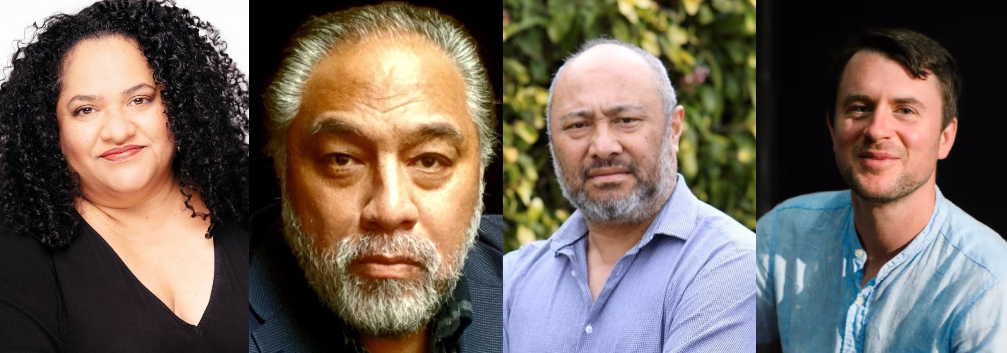
Opera Australia and the Australian Museum join forces for a celebration of Pasifika voices

L-R Heru Pinkasova, Eddie Muliamaseali’I, Niulala Helu, Chad Kelly

Sydney, Tuesday 21 October: Opera Australia and the Australian Museum (AM) will collaborate on Yumi Bung Wantaim: Songs of Gathering, a historic event that brings together renowned Pasifika artists, community voices, and the Opera Australia Orchestra, in the Australian Museum’s Hintze Hall, for a powerful evening of music, storytelling, and celebration.
This first-of-its-kind collaboration is a tribute to ancestry, resilience and identity. Weaving together traditional Pasifika songs and operatic masterpieces, the performance honours the rich heritage of Australia’s Pacific neighbours, and Pacific diaspora.
The concert features Samoan bass-baritone Eddie Muliamaseali’i, Papua New Guinean soprano Heru Pinkasova, and Niulala Helu, Director of Tonga’s Afokoula, who will lead the Tautahi Choir under the baton of conductor, Chad Kelly.
“This event represents an important step for Opera Australia, it’s a moment to say to all communities: opera is for you, your stories belong on our stages, and we are listening,” said Simon Militano, Acting CEO of Opera Australia.
Director and CEO of the Australian Museum, Kim McKay AO, said hosting the performance at the Australian Museum would add a deeper sense of community connection to Pasifika cultural knowledge, which is vital part of the AM’s world-renowned collection.
“The Australian Museum works closely with communities from across the Pacific region to maintain and interpret the museum’s Pasifika collections, the largest in the world, and promote greater understanding of these vibrant and diverse cultures. By collaborating with Opera Australia, we have a moment to celebrate a remarkable region that covers a third of the earth, and speaks a quarter of the world’s languages,” Ms McKay said.
The performance also marks a significant year for the Pacific region’s independence with multiple milestone constitutional anniversaries being celebrated this year, adding further dimension to Yumi Bung Wantaim’s stories of identity.
In elevating Pasifika talent and showcasing the deep connections between music, place, and story Yumi Bung Wantaim seeks to find harmony between the western opera canon and traditional Pasifika music, where Mozart and Pasifika song stand side by side.
“This concert is a powerful reminder of how opera can be a force to bring people together, and that by singing together we are all connected; our cultures and communities are all connected,” said Nathan Gilkes, Head of Education, Learning and Participation at Opera Australia.

Melissa Malu, Head of Pasifika Collections & Engagement at the Australian Museum, said the AM and Opera Australia share a commitment to storytelling and celebration.
“For Pasifika peoples, singing and chanting have always carried our histories, values, and identities from generation to generation. This concert celebrates those living traditions, showing how our ancient stories continue to speak powerfully in contemporary spaces.
"In a time when cultural understanding and inclusivity are more important than ever, this event sets a new benchmark for artistic collaboration and cultural knowledge sharing,” Melissa Malu said.
The fully subscribed event with over 300 attendees will take place in the Australian Museum’s Hintze Hall on Tuesday, 21 October from 6.30pm - 7.40pm. For more information visit: australian.museum/event/songs-of-gathering/

Media enquiries
Analisse Lettieri | Publicist | +61 488 244 750 | analisse.lettieri@opera.org.au
Australian Museum | media@australian.museum

About the cast and creatives
Eddie Muliamaseali’i
New Zealand born of Samoan heritage, Eddie Muliaumaseali'i's career has spanned almost 40 years beginning in 1987. Now based in Melbourne, he has performed in opera, musicals, plays as well appearing in Television soap opera around the world. Eddie has done the most tours in Australian Opera History as a singer with Opera Australia, Co-Opera South Australia, Melbourne Opera, Opera Queensland amassing over 25 tours from 1996 to 2025. He also developed education workshops with OzOpera alongside touring productions Australia-wide. Having sung in Austria, Samoa, PNG, United Kingdom, Germany, USA, China, Spain and traversing over 300,000kms around Australia, Eddie has a heart for the regions and communities of Australia.
Heru Pinkasova
A Papuan-Australian songstress whose artistry blends opera, ancestral song, and contemporary storytelling. Born in Port Moresby and raised in Cairns, she has performed across Australia and Europe, from Kaurna language works with Australian Dance Theatre to Andrée Greenwell’s Three Marys at the Sydney Opera House. Her creations, including Bilum Mamma, Songs My Aunties Taught Me, and her solo recital Pacific Harmonies for Opera Queensland’s Studio Series, honour her heritage while embracing new sounds. Based in Brisbane, she collaborates with Opera Queensland and serves on the Board of Springboard Opera.
Niulala Helu
As a young man he sang and performed traditional, classical Tongan choral and operatic repertoire. Niulala took his knowledge to the US, Europe and Oceania as a choreographer and performer with the ‘Atenisi Foundation for performing Arts, eventually settling in New Zealand where he taught Pacific dance forms and theory at Auckland University and AUT University. He is now a teacher at Epsom Normal School in Epsom, Auckland.
Chad Kelly
A British keyboardist and director, with an extensive musical career throughout the world. Chad spent several seasons at the Bavarian State Opera (Munich) and at English National Opera (London) before joining Opera Australia in 2022, with a strong commitment to historically-informed performance practice. Chad studied at Cambridge University and at the Royal Academy of Music. He became Lector in Music at Trinity College, Cambridge, and was elected Associate of the Royal Academy of Music in recognition of his contribution to the music profession. He continues his nurturing of young musicians as a guest lecturer at the Guildhall School of Music and Drama and at the University of Melbourne.
About the Australian Museum
The Australian Museum (AM) was founded in 1827 and is the nation's first museum. It is internationally recognised as a natural science and culture institution focused on Australia and the Pacific. The AM's mission is to ignite wonder, inspire debate and drive change. The AM's vision is to be a leading voice for the richness of life, the Earth and culture in Australia and the Pacific. The AM commits to transforming the conversation around climate change, the environment and wildlife conservation; to being a strong advocate for First Nations cultures; and to continuing to develop world-leading science, collections, exhibitions and education programs. With 22 million objects and specimens and the Australian Museum Research Institute (AMRI), the AM is not only a dynamic source of reliable scientific information on some of the most pressing environmental and social challenges facing our region, but also an important site of cultural exchange and learning.

